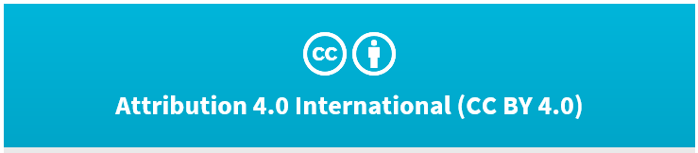
Releasing Council Geospatial Data

Need some help working through the CC BY and how to do it simply and easily?
Below is a quick start guide on this subject.

Creative Commons Attribution 4.0 International License (CC BY 4.0). Under this license you are free to copy, distribute, and adapt the work. You must however attribute the Data to the Data Owners and abide by the license terms and conditions. To view a copy of this license, visit https://creativecommons.org/licenses/by/4.0/.

Creative Commons licensing can be used to release the bulk of Geospatial data. Creative Commons Attribution 4.0 New Zealand International License (CC BY 4.0) is the most appropriate licence to use.

Prior to release, the data needs to be checked to ensure:

- It belongs to the council who intends to give it out
- It can be provided
- It has quality metadata
The issuing council is responsible for performing this check. If it doesn’t meet these criteria it cannot be provided.

Justification for this decision
New Zealand has a strong history of open and transparent government that is internationally recognised. One of the pillars of open and transparent government is open government data and information.

Evidence suggests that opening up this information for re-use has considerable and widespread benefits to government, industry and the public. At the same time, technological and cultural advances also make it cheaper and easier to do.

A number of resources have been referred to in arriving at the above standpoint. These include:
NZGOAL Advice on using the Creative Commons licenses – Legal opinion from A J Park, 14 April 2011

Guidance and resources with more detail:

- http://ict.govt.nz/guidance-and-resources/open-government/new-zealand-government-open-access-and-licensing-nzgoal-framework/
- €http://www.creativecommons.org.nz/

Providing council geospatial data in an email
When sending data (whether it be general geospatial data, aerial images or LIDAR) in an email the following could be used as a template:

*****************

Hi XX,

Creative Commons Attribution 4.0 International License (CC BY 4.0). Under this license you are free to copy, distribute, and adapt the work. You must however attribute the Data to the Data Owners and abide by the license terms and conditions. To view a copy of this license, visit https://creativecommons.org/licenses/by/4.0/.
If you do not accept the terms of the Creative Commons 4.0 International Licence then please delete this email and data.

[Your email content can now go here]

Kind regards,

[Your name and email signature]

*****************
Providing council geospatial data in person
When providing geospatial data in person the handover should be arranged via email using the above email template. A readme file containing the above agreement should be placed on the device alongside the data. In addition you should advise them in person that the data is released under the teams above and by using it they agree to these terms.

Providing council data in a web interface
When providing data using a web interface the following should be used as a click through agreement:

*****************
Copyright ©. This copyright work is licensed under the Creative Commons Attribution 4.0 International licence. In essence, you are free to copy, distribute and adapt the work, as long as you attribute the work to [ABC Council] and abide by the other licence terms. To view a copy of this licence, visit https://creativecommons.org/licenses/by/4.0/

If you do not accept the terms of the Creative Commons 4.0 International Licence then please do not proceed.

This application uses data sourced from [ABC], [DEF], [HIJ]
*****************

